

Assignment1 Game Development

Bahman Yaghoubi Vije



October 26, 2016

Student Id: 100968843

Table of Contents

Detailed Game Description 2

Controls description 2

Interface Sketch 2

Screen Descriptions 3

Start State: 4

Boss Monster State 4

Resizing State 5

Game Over State 5

Win Sate 6

Enemies 6

Sword 6

Boss Monster 6

Scoring 6

Sound Index 7

Art / Multimedia Index 8

# Detailed Game Description

A naughty fox is hungry, and wants to catch and eat birds. The farmer is not happy with the fox intend, and tries to prevents him by throwing swords towards him. The fox gains points by catching birds, and looses health by getting hit by swords. If the fox survives from the swords, and reaches 150 points, the farmer gets angrier and starts to throw flames as well. Eating 20 birds (gaining 200 points) gives the fox a magic power, so he would be able to resize himself to a smaller version, and this helps him avoid swords and flames easier. Finally, if the fox eats 25 birds and gains 250 points, he will win, and become the master of the farm.

# Controls description

The fox (player) is controlled by user. In order to control it, user can use arrow keys, as well as standard keys:

* Right arrow and D key moves it to right.
* Left arrow and A key moves it to right.
* Up arrow and W key moves it to right.
* Down arrow and S key moves it to right.

The swords and the flame (Enemies) are controlled by the machine and user has no control over them. Birds are also controlled by the machine.

# Interface Sketch

The game has only one scene. Here is a wireframe of the game:

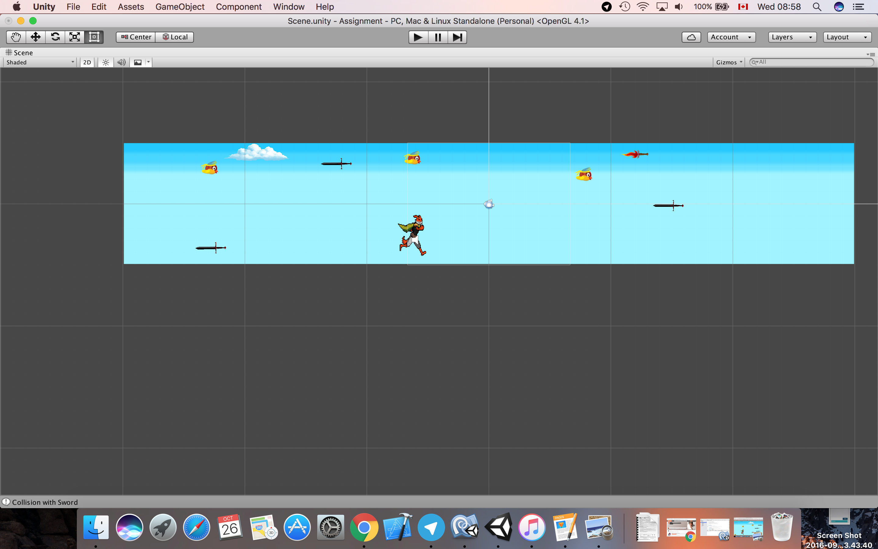

Here is another image showing the whole canvas:

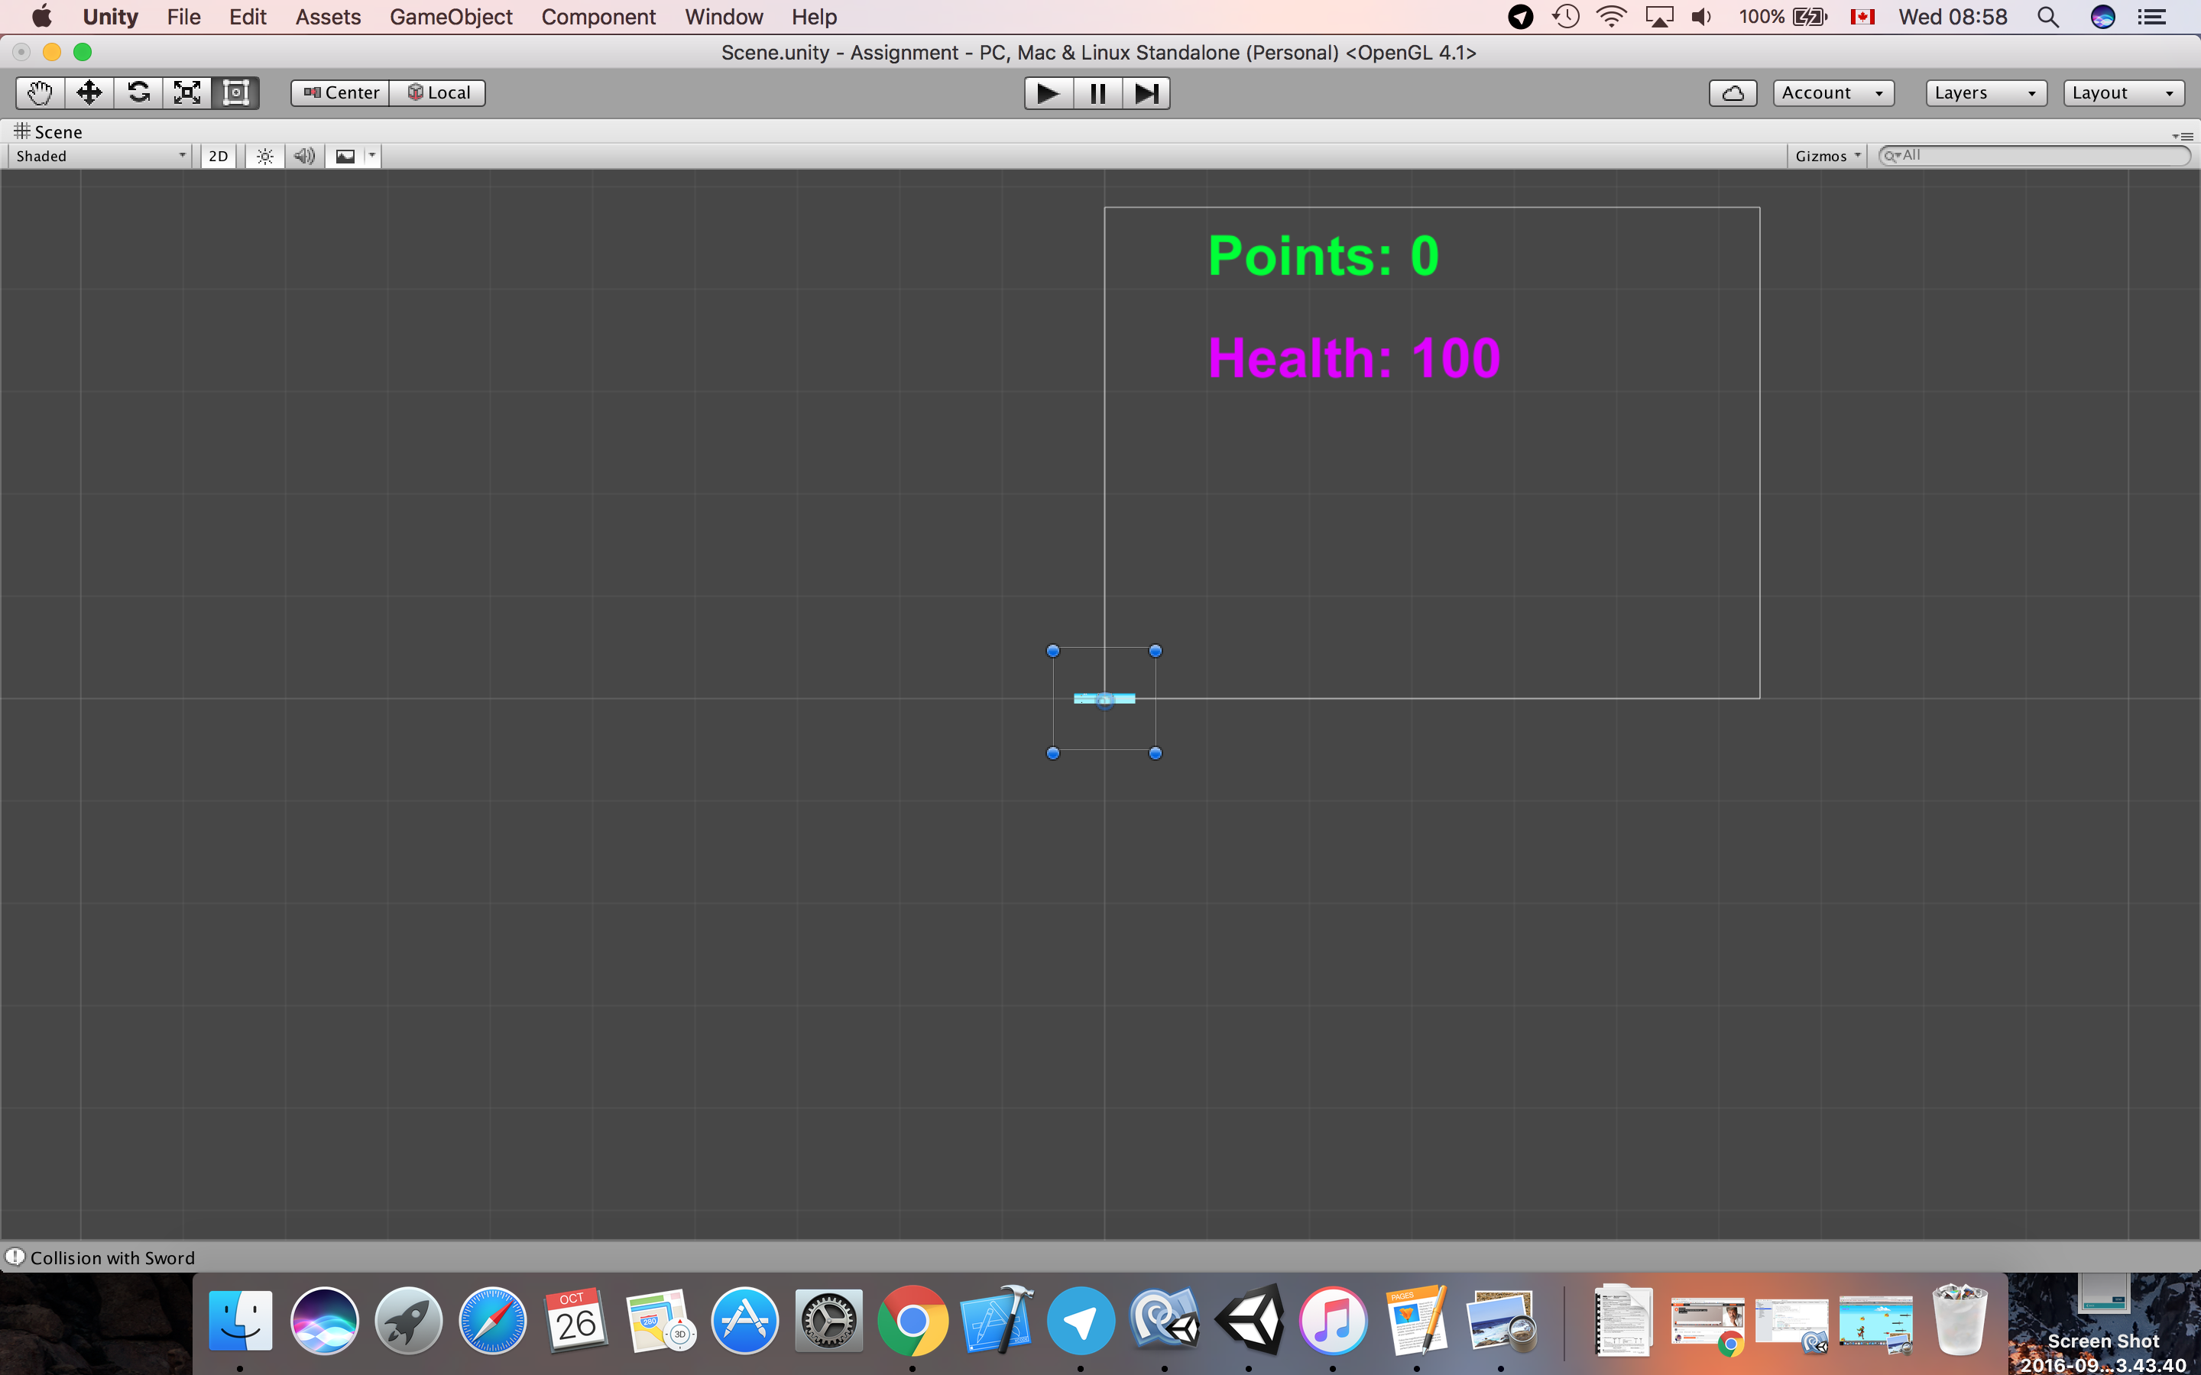

# Screen Descriptions

Here are a few screenshots from the game:

## Start State:

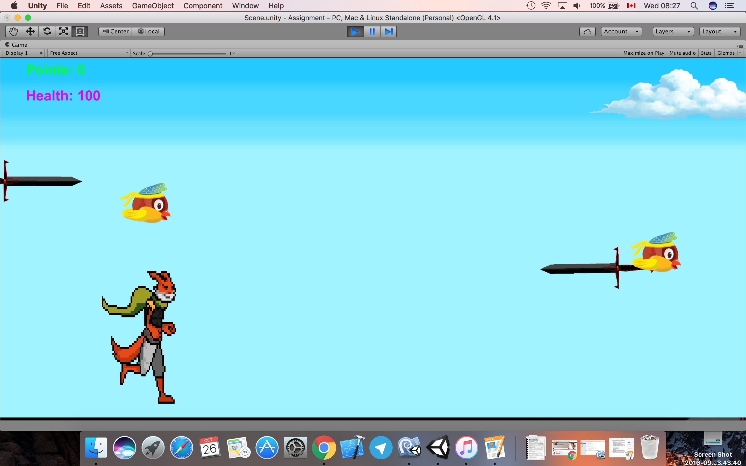

## Boss Monster State

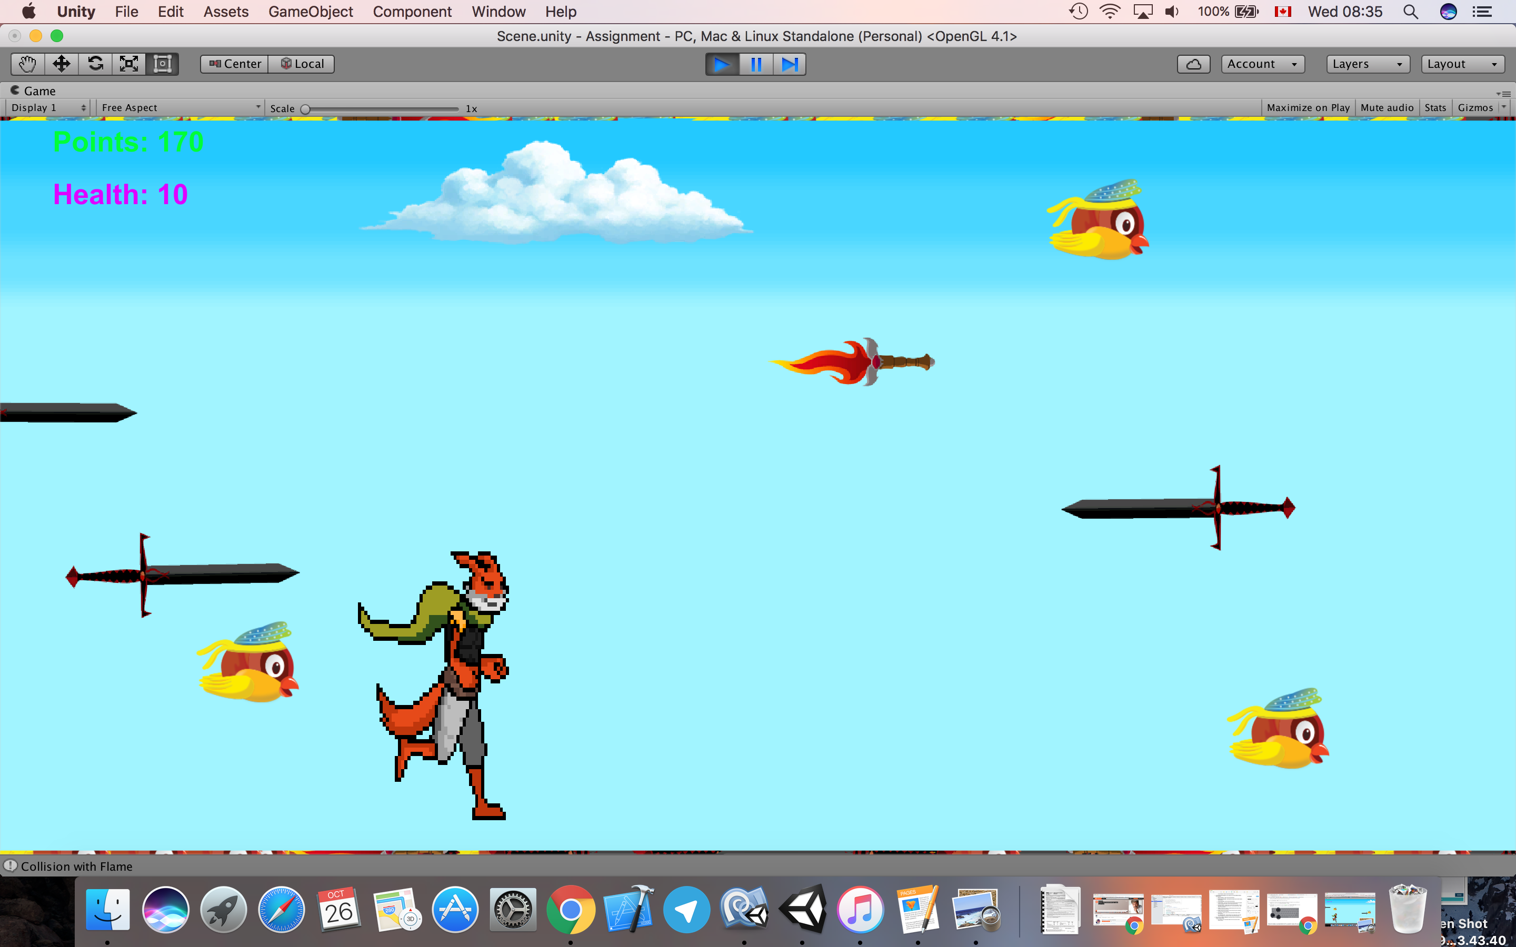

## Resizing State

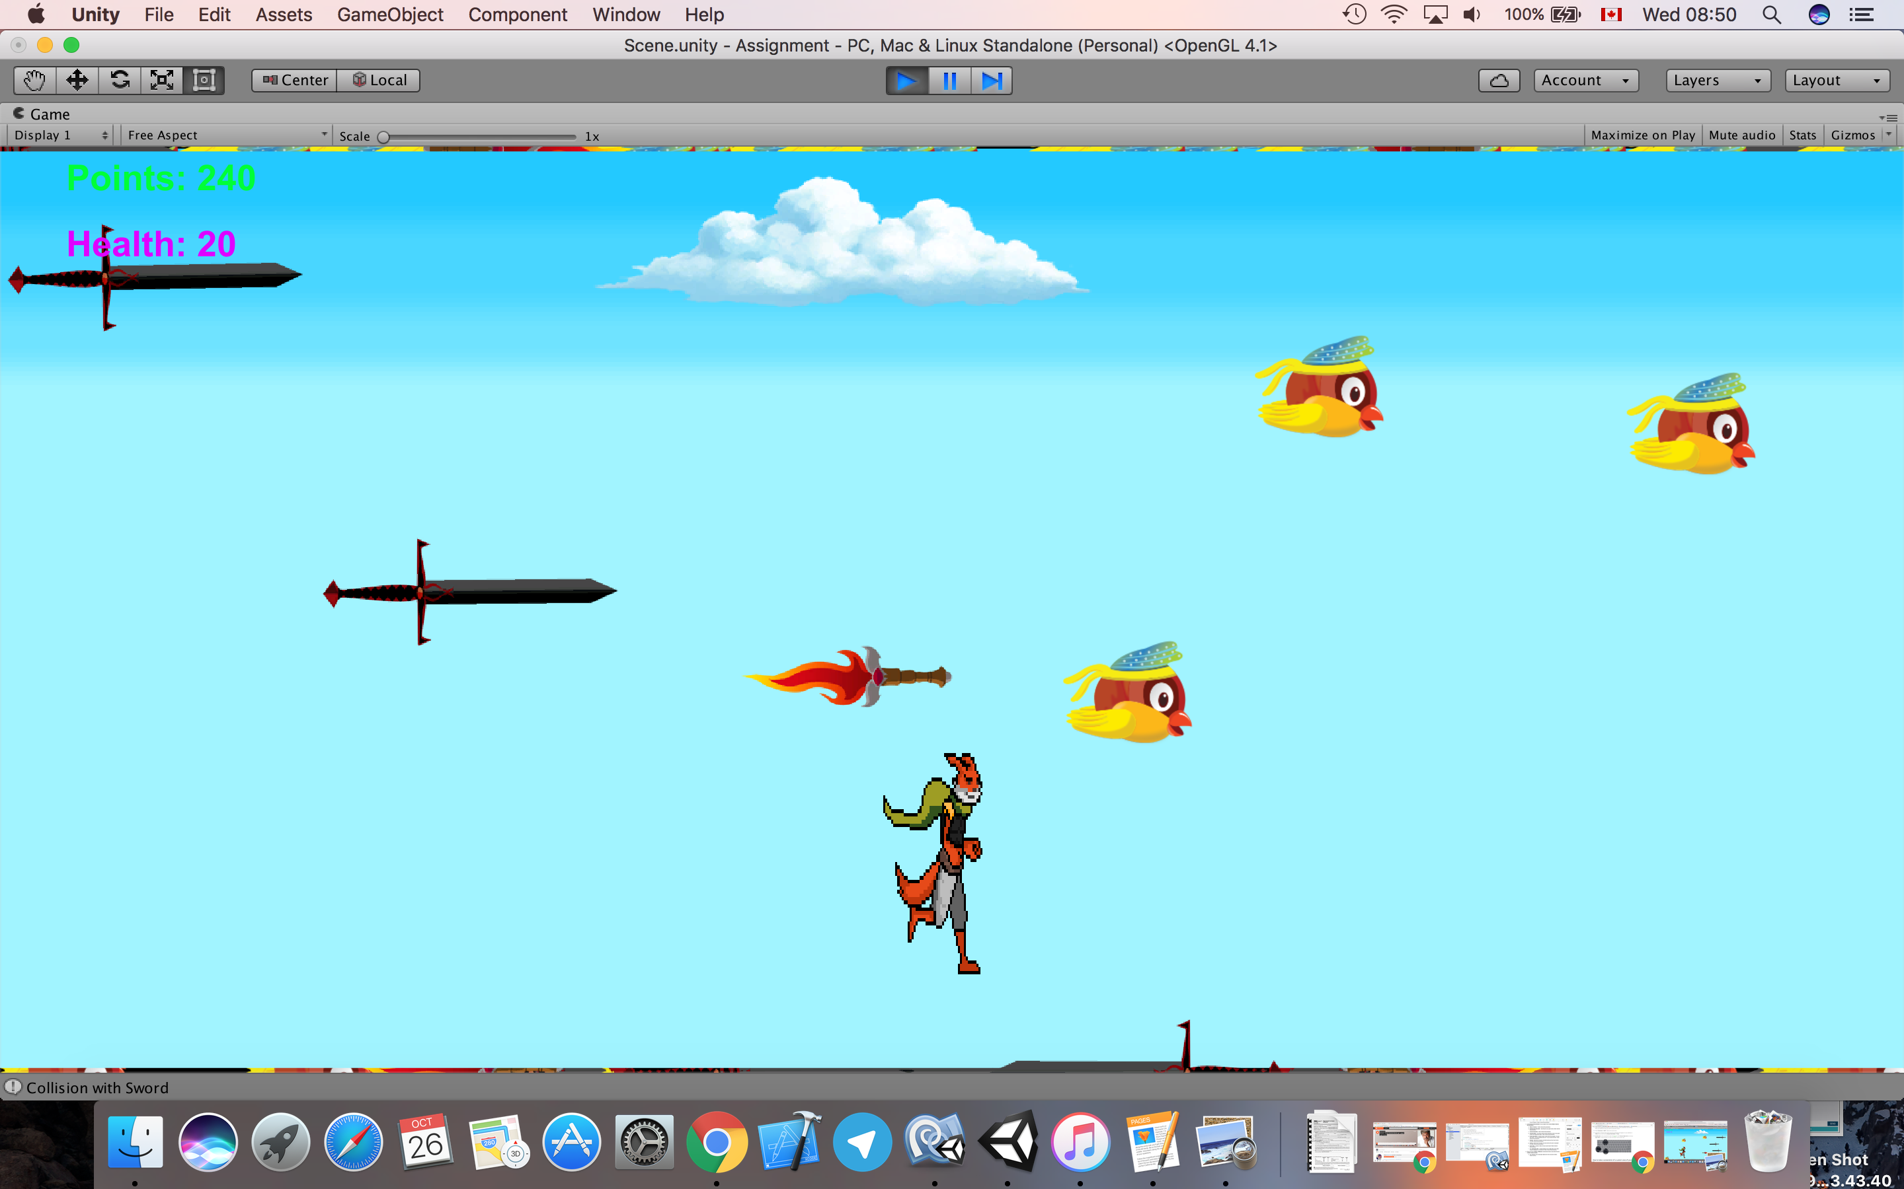

## Game Over State

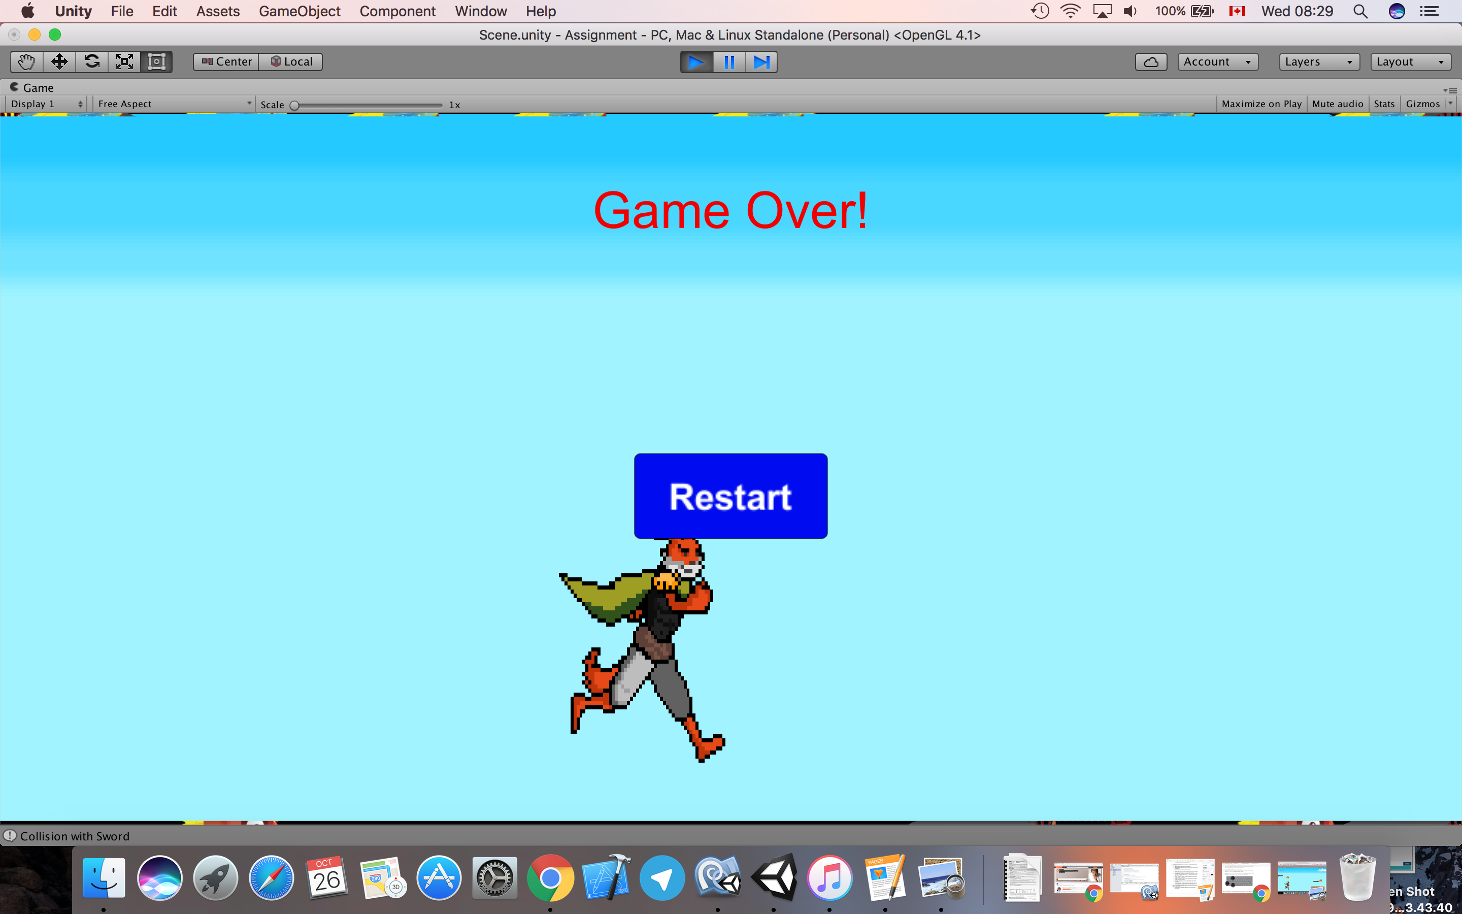

## Win Sate

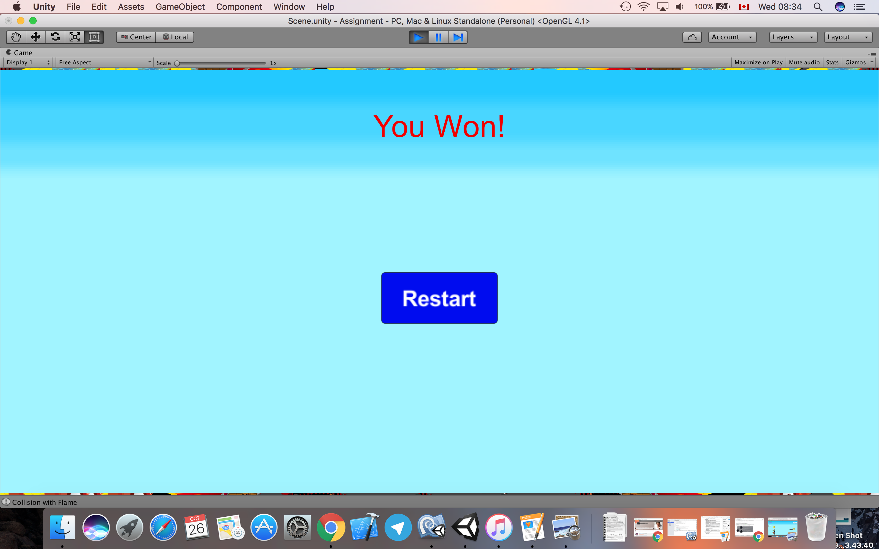

# Enemies

The game has two types of enemies:

## Sword

The sword comes from some point with a random height and moves with a fixed speed from top to down of the scene. When it reaches a certain point at the lower edge of the scene, its position resets. The swords move in two different directions to make it harder for the fox to avoid collision. The direction of the swords is defined randomly for each object. Three swords may come to the scene at the same time. If a sword hits the fox, the fox’s health will be reduced by 10.

## Boss Monster

The flame starts showing up when the fox reaches 150 points. There would be just one object of flame at the scene. Flame moves at a higher speed comparing to swords. If a flame hits the fox, the fox’s health will be reduced by 5.

# Scoring

Whenever the fox catches a bird, it gains 10 points. The game’s state changes once when the fox gains 150 points and once when it gains 200 points. The game could be won when the fox gains 250 points. The game is over (and user looses the game) when the health becomes 0, and the points has not reached to 250.

# Sound Index

|  |  |  |
| --- | --- | --- |
|  | Audio Name | URL of the source |
|  | Background | https://www.assetstore.unity3d.com/en/#!/content/60232 |
|  | Yeah | https://www.assetstore.unity3d.com/en/#!/content/62378 |
|  | Hit | https://www.assetstore.unity3d.com/en/#!/content/62378 |
|  | No | https://www.assetstore.unity3d.com/en/#!/content/62378 |
|  | Death | https://www.assetstore.unity3d.com/en/#!/content/62378 |
|  | Win | https://www.assetstore.unity3d.com/en/#!/content/16644 |

# Art / Multimedia Index

|  |  |  |  |
| --- | --- | --- | --- |
|  | Image Name | URL of the source | Image |
|  | Sky | https://i.ytimg.com/vi/lIX2-UKKvZA/maxresdefault.jpg | C:\Users\Bahman\Downloads\Telegram Desktop\Assets\Sky.png |
|  | Cloud | https://www.assetstore.unity3d.com/en/#!/content/58833 | C:\Users\Bahman\Downloads\Telegram Desktop\Assets\Cloud.png |
|  | Fox | https://www.assetstore.unity3d.com/en/#!/content/59175 | C:\Users\Bahman\Desktop\Fox.png |
|  | Bird | https://www.assetstore.unity3d.com/en/#!/content/27774 | C:\Users\Bahman\Downloads\Telegram Desktop\Assets\Bird.png |
|  | Sword | https://www.assetstore.unity3d.com/en/#!/content/18270 | C:\Users\Bahman\Desktop\Sword.png |
|  | Flame | https://www.assetstore.unity3d.com/en/#!/content/18270 | C:\Users\Bahman\Desktop\Flame.png |